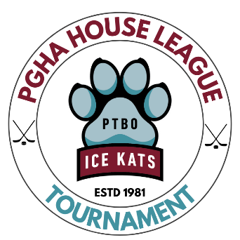

Peterborough Girls Hockey Association
House League Tournament
Hotel Information

Comfort Hotel & Suites - Website
1209 Lansdowne St W,
Peterborough, ON K9J 7M2
Phone: (705) 740-7000

Holiday Inn Waterfront - Website
150 George St N,
Peterborough, ON K9J 3G5
Phone: (705) 743-1144

Best Western Otonobee Inn - Website
84 Lansdowne St E,
Peterborough, ON K9J 7N9
Phone: (705) 742-3454

Quality Inn Peterborough - Website
1074 Lansdowne St W,
Peterborough, ON K9J 1Z9
Phone: (705) 748-6801

Super 8 Peterborough - Website
1257 Lansdowne St W,
Peterborough, ON K9J 7M2
Phone: (705) 876-8898

Motel 6 Peterborough - Website
133 Lansdowne St E,
Peterborough, ON K9J 7P7
Phone: (705) 748-0550

